**Practical – 3**

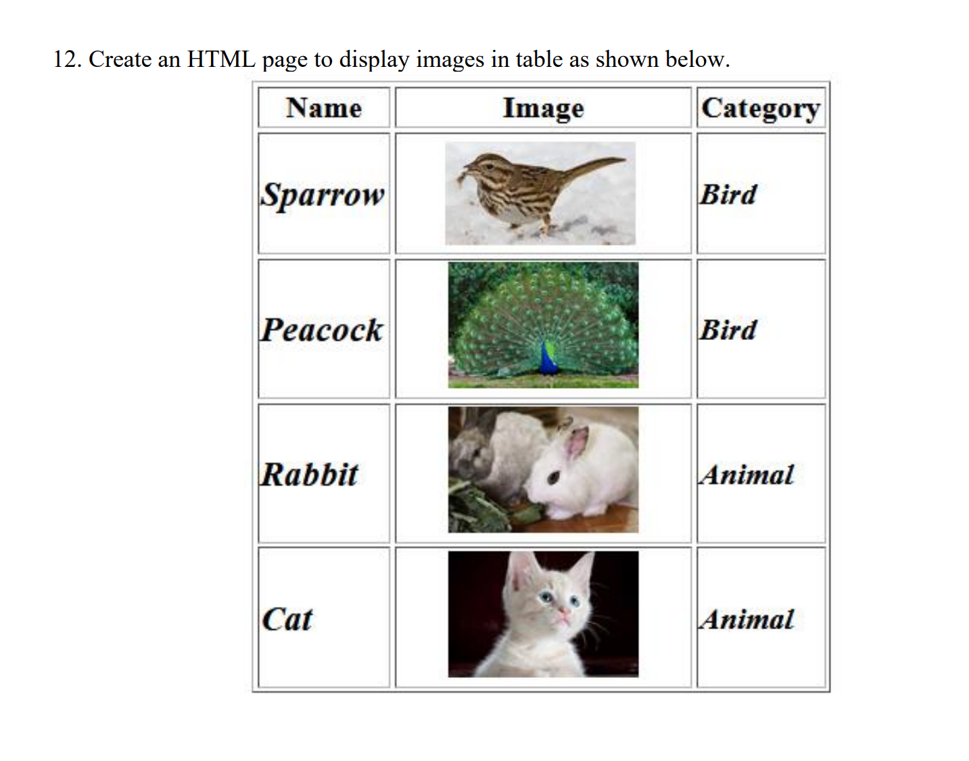

**HTML Code**

<!DOCTYPE html>

<html lang="en">

<head>

<meta charset="UTF-8">

<meta name="viewport" content="width=device-width, initial-scale=1.0">

<title>Rowspan & Colspan </title>

</head>

<body>

<table border="2">

<tr>

<th>Name</th>

<th>Image</th>

<th>Category</th>

</tr>

<tr>

<td><b><i>Sparrow</i></b></td>

<td><img src="/Question 12/sparrow.jpg" height="50px" alt=""></td>

<td><b><i>Bird</i></b></td>

</tr>

<tr>

<td><b><i>Peacock</i></b></td>

<td><img src="/Question 12/peacock.jpg" height="50px" alt=""></td>

<td><b><i>Bird</i></b></td>

</tr>

<tr>

<td><b><i>Rabbit</i></b></td>

<td><img src="/Question 12/rabbit.jpg" height="50px" alt=""></td>

<td><b><i>Animal</i></b></td>

</tr>

<tr>

<td><b><i>Cat</i></b></td>

<td><img src="/Question 12/cat.jpg" height="50px" alt=""></td>

<td><b><i>Animal</i></b></td>

</tr>

</table>

</body>

</html>

**Output**

